**IoT Based Smart Drainage System in Dhaka City**

Taufiq Ahmed

Department of CSE

Daffodil International University

Dhaka, Bangladesh

[taufiq15-11129@diu.edu.bd](mailto:taufiq15-11129@diu.edu.bd)

Fazle Rabby Talukder

Department of CSE

Daffodil International University

Dhaka, Bangladesh

[fazle15-11022@diu.edu.bd](mailto:fazle15-11022@diu.edu.bd)

MD. Al amin Hosen

Department of CSE

Daffodil International University

Dhaka, Bangladesh

[alamin15-11132@diu.edu.bd](mailto:alamin15-11132@diu.edu.bd)

**Abstract:** Waterlogging is a great concern for the people who live in the city of Dhaka. In rainy reason when it rains a little, the roads of Dhaka get flooded. Due to waterlogging, there are many problems in the movement of vehicles on the road. The main reason for this problem is the blockage of the drain. Every day lots of waste and trash is being thrown into the drain that blocks the water flow. Very few works have been done on this issue in terms of Bangladesh. So we address the problem and try to resolve the problem with the help of IoT. We try to build a prototype that can easily detect the blockage and automatically free that blockage without the help of human beings.

**Keywords:** Arduino, IoT, Smart drainage system, Water flow, and level sensor, Arduino.

**Introduction:**

Dhaka is one of the most populous cities in the world. Statistics show around 21 million people live in Dhaka city till 2020. Since Dhaka is the capital city of Bangladesh, innumerable people come to Dhaka from rural areas every year. As a result, the amount of waste and garbage is increasing drastically. Sometimes this dirt falls into the drain and disrupts the flow of water. During monsoons, waterlogging is caused due to the inability of rainwater to travel through the drains. Over the last few years, the amount of rainfall in Dhaka city has increased due to which the waterlogging has increased as well. According to the Statista report, the amount of annual rainfall in Dhaka city is 2076 mm. The consequence of this problem is serious. Transportation systems collapse during this time so that jobholders cannot reach the office on time also students cannot reach their institutions.

It is quite impossible to detect all the blockage of the drain by using manpower. So IoT has come to save us from this problem. many developing countries of the world Have made new smart cities through IoT. So, we can use this technology in Dhaka city to build a smart drainage system that can resolve the waterlogging problems.

In this research, we thoroughly observed the problem with the traditional drainage system and why it has failed to save from waterlogging. We have found that due to human unconsciousness, this blockage is made. Most people do not throw waste in the proper place So when it rains all the waste goes into the drain and blocks the face of the drain.

After Investigate all the above things we have tried to build a smart drainage system. When it rains, the drain’s face will be monitored by some smart sensors like water flow sensors, water level sensors. So, whenever the sensor detects any block, it informs the system, and the system will try to remove the block with the help of a DC motor.

The model will perform in three stages. In the first stage, the model will try to detect whether any blockage occurs or not. In the second stage, the main system will decide by analyzing the monitoring stage result. Finally, in the last stage, the model will try to remove the blockage whenever it gets a command from the decision stage. It is high time to use technology to prevent drainage problems in Dhaka city.

**Literature review:**

In recent years many works have been done to develop smart cities based on IoT. But none of them are specifically based in Dhaka city. The reason behind this massive and serious problem is the old drainage system, lack of maintenance, and excessive rainfall [3]. The natural drainage system of Dhaka cities like ancient canal and many rivers which situated beside Dhaka is also losing its life [2]. In Dhaka lots of people throw waste like plastic tier scrap here and there that ultimately block the drain and water cannot pass through it. So, it is high time to introduce digital technology like IoT, Nural networks to prevent this issue [4]. An experiment is already conducted in Hong Kong to predict waterlogging in monsoons [1]. Moreover, IoT-based dirt and drainage systems also perform well and bring a good result for the city’s people [5]. That’s the reason we try to implement it into Dhaka city to observe its efficiency. In previous work, most of the results are far better than the traditional drainage systems. Even our neighboring country Sri Lanka they have also experimented with a road monitoring system [6]. However, Bangladeshi researchers are also using Arduino in various sectors. Among them, Agriculture is highly noticeable [7]. Tes most obvious reason for using Arduino is it is cheap, open-source, and easy to use. That’s the reason we thought it would not be a bad idea to encounter Dhaka’s waterlogging problem with this smart device.

**Problem Formulation:**

There are two city corporations in Dhaka City. Dhaka north and Dhaka south. The two city corporations have taken lots of initiative to reduce waterlogging. Two major rivers flow through Dhaka city. One is Buriganga and the other one is Turag. From the beginning of the city, all the water of Dhaka city went directly to these rivers. Over time, the rivers began to fill up as the population grew. So, the two city corporations have started to rescue work to restart the rivers again. Although they are trying to rescue the rivers, the drain blockage remains due to the lack of proper monitoring. Apart from this city corporations use manpower who detect the block, but it is impossible to detect all the blocks for human beings. We must bring technology to deal with this problem.

Most of the drain was made many years ago. During that time the population of Dhaka city was very few as compared to today’s population. Also, the drainage system was backdated. If we see today’s Developing country’s use smart drainage systems. In Dhaka’s drainage system the drains and pipes are very thin so whenever some waste is thrown into this drain it blocks the face of the drain. Every year during the monsoons, two city corporation enrich their manpower to prevent this blockage. It cost them lots of money and time. Nevertheless, they cannot detect all the blockage properly. However, we have to think about alternative ways to prevent the problem.

The best way to save Dhaka from waterlogging problems is by monitoring the drainage system environment. Unfortunately, Dhaka city corporations do this task manually. When city corporation’s officials notice reports from specific areas residents about waterlogging, they go there and solve it. This procedure takes lots of time and local civilians suffer a lot. Our economy also hampers this situation. Because waterlogging caused a huge traffic jam in the city so workers cannot reach the theory workplace on time. Academic institutions also face problems due to this waterlogging. However, a serious problem that authors notice is that sometimes lots of ambulances get stuck with dying patients due to this traffic jam. So, we can say not only the economy but also the life of innocent people is damaged because of this waterlogging. City corporations need to take different approaches to monitor the situation and act.

**Methodology:**

***Necessary equipment:***

**1.Arduino UNO:**

Arduino UNO is an open-source microcontroller based on ATmega 328P and its clock speed is 16 MHz. It has a good user-friendly interface so anyone from another domain can easily deal with it. Some specifications about Arduino UNO are given below. Its operating system is 5 volts, and the Input voltage is 7-12 volt. It has 14 digital input-output, among them 6 provide PWM output. Apart from this, there are 6 analog input pins. Moreover, its memory specification is given below respectively, Flash memory 32 KB, SRAM 2 KB, and EPROM 1 KB.

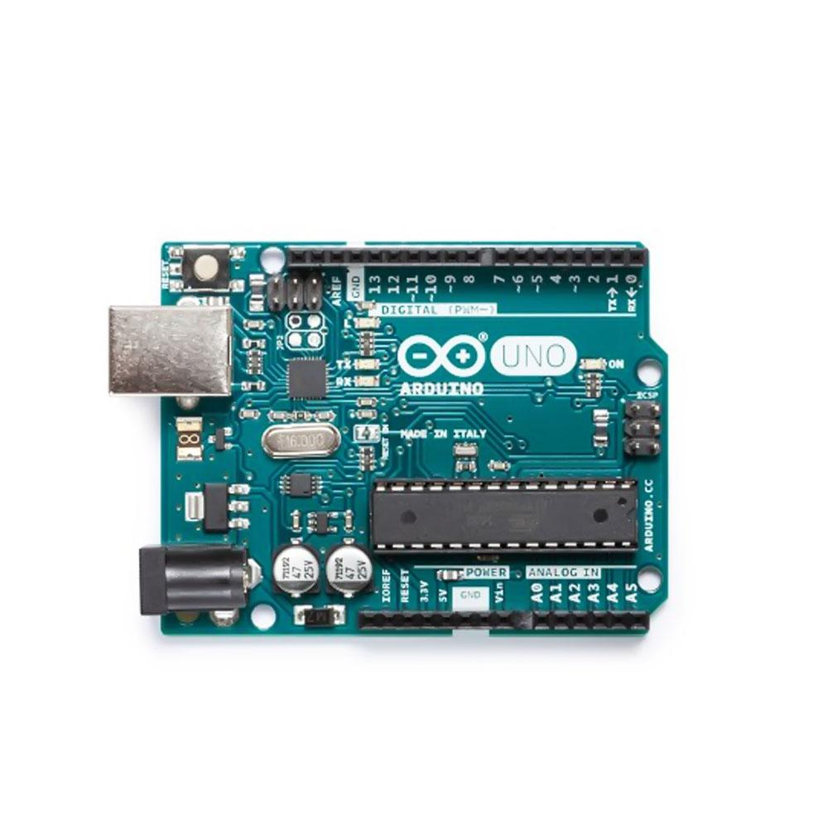

Figure: Arduino UNO

**2.Water level sensor:**

The hardware of the water level sensor is very simple. There are ten exposed copper trades on the sensor, five of which are power traces and five of which are sensing traces. And an LED to indicate the power. This sensor also works in a very straightforward way. Those exposed conductors work kile variable resistors. So, the value of those resistors varies with respect to the water level. More water indicates low resistance.

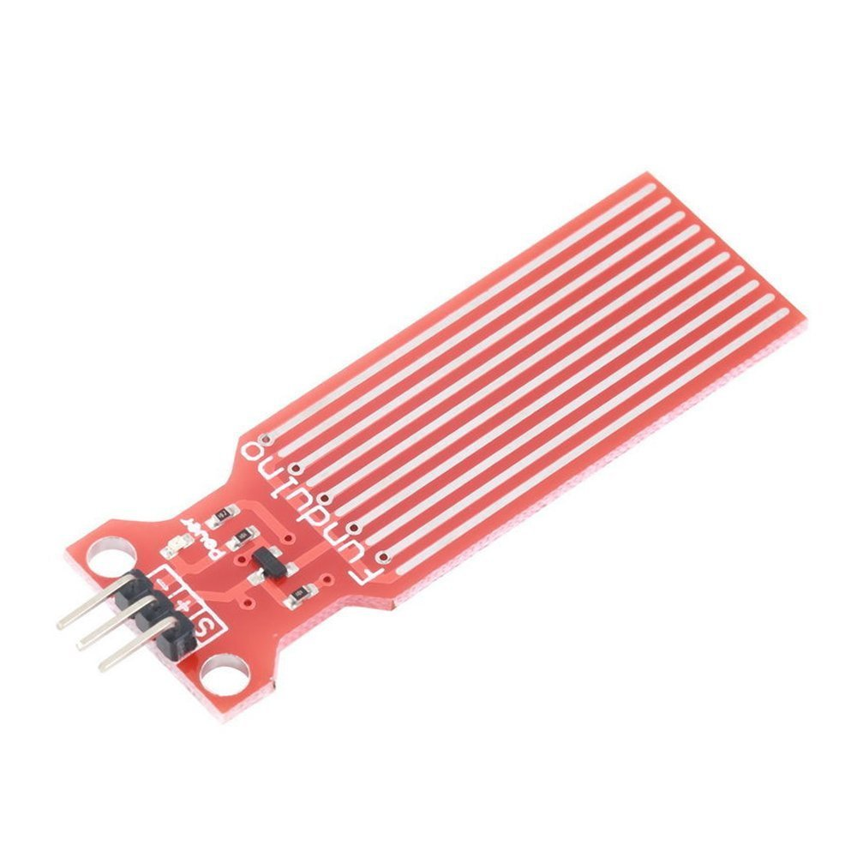

Figure: water level sensor

**3.Water flow sensor:**

The water flow sensor is nothing, but a copper body, a water rotor, and a hall-effect sensor make up a water flow sensor. When water runs through the rotor, the rotor rolls at a variable speed depending on the rate of flow. The main component of this sensor is magenta, turbine wheel and hall effect sensor. Whenever water passes through this sensor the wheel rotates and by calculating its rotation and covert it in square wave output (pulse) we can measure the flow of water.

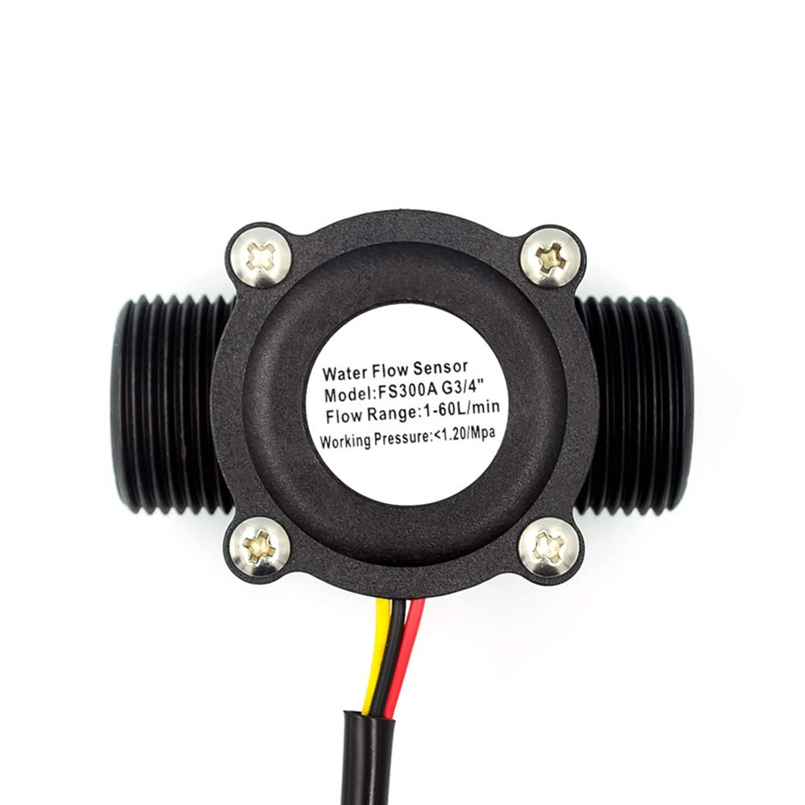

Figure: water flow sensor.

**4.Relay:**

A relay is nothing but a smart switch that can turn off and on by Arduino switch. Nowadays it has become so popular because it helps a lot to control IoT devices from a long distance. Most of the smart appliances that are available on the market are using the relay to make them more attractive to the users.

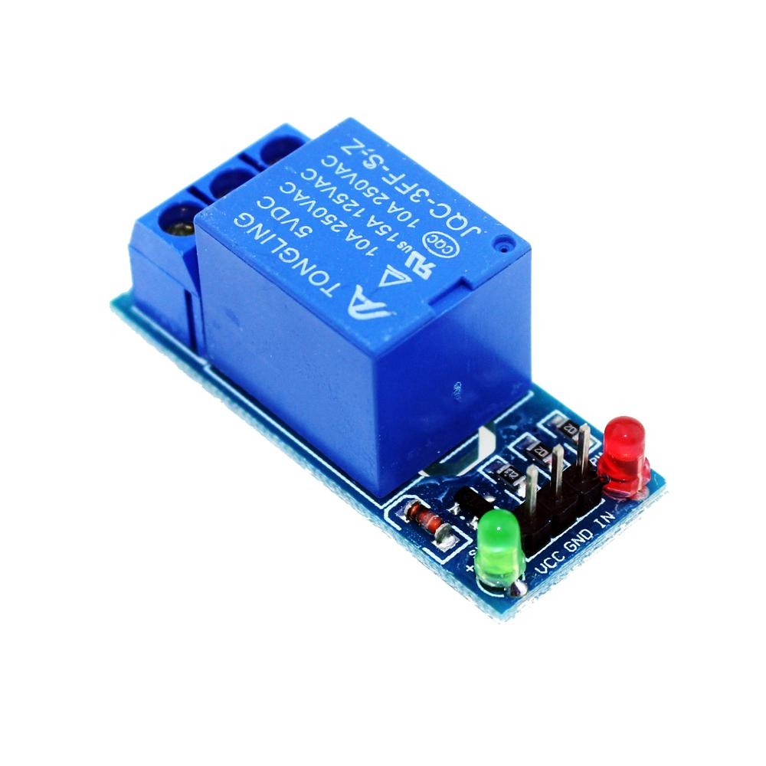

Figure: relay

**5.DC motor:**

DC motor is the most simple and common motor that can be operated through Arduino. It is also simple to use. It just has two leads, positive and negative. If we connect positive and negative directions with a battery the motor will rotate. If we want to rotate is in the opposite direction all we need to do is switch the leads. Whenever we need force on our system we use this DC motor. For example, a robotics car uses a DC motor in ti’s wheel to rotate. It’s also used to pump water.

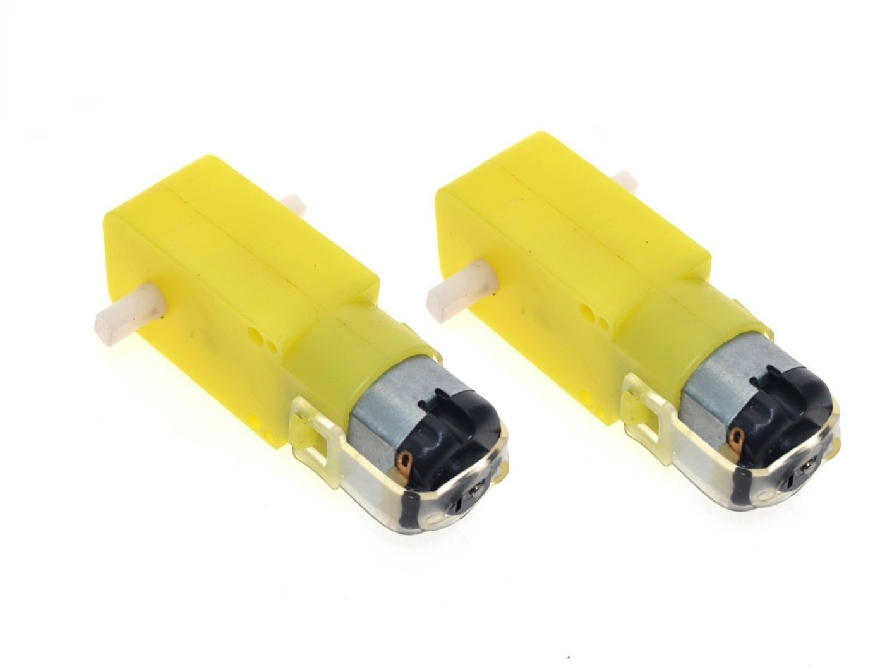

Figure: DC motor.

***Proposed method:***

For the abovementioned problem, we design an Arduino-based smart drainage system that can monitor the situation of the drainage system and take action whenever needed. We hope it will boost the efficiency of Dhaka’s drainage system.

The proposed methods and diagrams are elaborately described in this section. The system has three different sections. They are the monitoring section, the decision section, and the prevention section. By using Arduino, we can easily monitor the situation and build communication among these sections. A figure of the proposed model and its working procedure is given below.

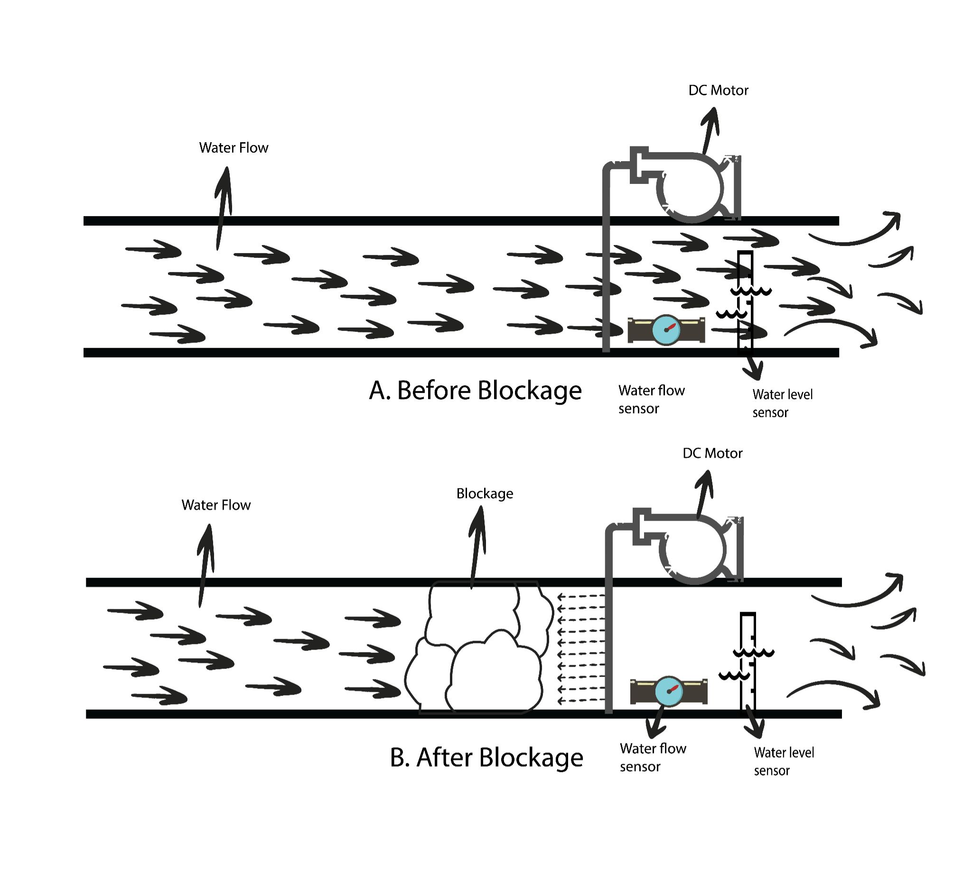

Figure: Proposed model of the system.

Firstly, In the detection section, several sensors are introduced to deflect the blockage of the drains. Water level sensor and water flow sensor is our most preferable sensor to work. These two sensors will work simultaneously and send data to the Arduino. Arduino is nothing but an easy-to-use electronic platform. We can write logic to collect data and take actions regarding the data. We will describe the procedure to set up and logic afterwords.

Secondly, there is a middle section where the Arduino system interprets the water level and flow rate. We will build logic in Arduino so whenever it detects some certain level of water and flow rate is stop it determined that the blockage has occurred. Otherwise, it considers a fine water flow. After making a certain decision it commands the prevention section what to do. If the decision section says clean the blockage the prevention section will work on that. The pseudocode of this system is given below,

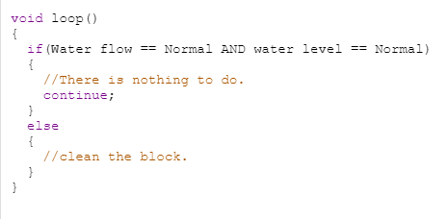

Figure: Main Logic of the system.

Finally, there is a prevention section. The main aim of this section is to open the blockage of the drain. When Arduino commands that the blockage has occurred, a powerful motor will throw water on the face of the blockage at a certain pressure. We know that if we throw high-pressure water the dirt removes from any surface. We try to utilize the same concept to clean the block. A high voltage DC motor will pump water from resources. and throw them in a great force towards the blockage. If storage water runs out and blocks still remain it will send a signal to Arduino to fill the water. The whole process in a flow chart is given below for better understanding.

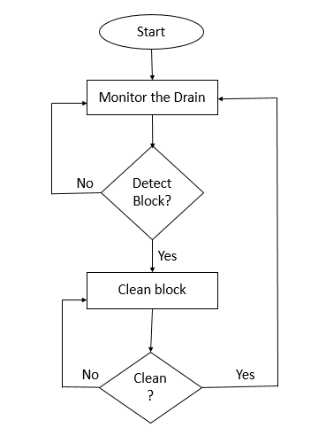

Figure: The system architecture.

**Result:**

This prototype is yet to be completed. We are trying to build this prototype by using some common sensors that are available on the market. We are hoping that the above-proposed method will work flawlessly. We will measure its result whenever the project is completed. When the project is completed our traditional drainage system will come under the umbrella of IoT. The system will automatically detect blockage and remove blockage without any human interaction. Most of the work will be done considering the expense. Due to the massive expansion of technology new and new technology and tools come to the market every day. Most of the tools and technology are designed to reduce expenses and enhance productivity. So, we are expecting that this model will reduce Dhaka’s city corporation’s present expense that they do for their manpower. So, they can use this saving expense on another project.

**Conclusion & Future Work:**

If we look at our ancient history most of our oldest civilizations developed on the bank of rivers. For instance, the Indus valley civilization developed on the bank of the Indus River, Egyptian civilization developed on the bank of the Nile River. So, we can understand the importance of water in human life. When civilization in Dhaka developed, they mostly depended on the Buriganga river. However, due to the misuse of this river, we are losing this beautiful river. Our government takes lots of initiatives to save this river, but the local city’s people throw waste on the drain and ultimately it goes to Buriganga. So, our future is to extend this drainage system and integrate a water purification system with this model to purify this drain’s water. So, we can save water for our future generation. Another future with this system is we want to farm fish in the drain killed Japan. So, it will help to meet the demand for protein in our country.

**Acknowledgment:**

The research is being done under the surveillance of MD. Fahad Faisal, Assistant professor. Department of Computer science and engineering, Daffodil International University. The author would like to thank the professor for this support and guidance.

**Reference:**

|  |  |
| --- | --- |
|  |  |
| 1. Keung, Kin Lok, Carman Ka Man Lee, K. K. H. Ng, and Chun-Kit Yeung. "Smart city application and analysis: Real-time urban drainage monitoring by iot sensors: A case study of Hong Kong." In *2018 IEEE International Conference on Industrial Engineering and Engineering Management (IEEM)*, pp. 521-525. IEEE, 2018. 2. Mowla, Qazi Azizul, and Mohammed Saiful Islam. "Natural drainage system and water logging in Dhaka: measures to address the problems." *Journal of Bangladesh Institute of Planners ISSN* 2075 (2013): 9363. 3. Tawhid, Khondoker Golam. "Causes and effects of water logging in Dhaka City, Bangladesh." *TRITA-LWR master thesis, Department of Land and Water Resource Engineering, Royal Institute of Technology, Stockholm* (2004). 4. Gupta, Apoorv, Aman Bansal, Rishab Gupta, Deepika Naryani, and Apoorvi Sood. "Urban waterlogging detection and severity prediction using artificial neural networks." In *2017 IEEE 19th International Conference on High-Performance Computing and Communications; IEEE 15th International Conference on Smart City; IEEE 3rd International Conference on Data Science and Systems (HPCC/SmartCity/DSS)*, pp. 42-49. IEEE, 2017. 5. Aarthi, M., and A. Bhuvaneshwaran. "Iot Based Drainage and Waste Management Monitoring and Alert System for Smart City." *Annals of the Romanian Society for Cell Biology* (2021): 6641-6651. 6. De Zoysa, Kasun, Chamath Keppitiyagama, Gihan P. Seneviratne, and W. W. A. T. Shihan. "A public transport system based sensor network for road surface condition monitoring." In *Proceedings of the 2007 workshop on Networked systems for developing regions*, pp. 1-6. 2007. 7. Akter, Sharmin, and P. Mahata. "Developing a smart irrigation system using arduino." *International Journal of Research Studies in Science, Engineering and Technology* 6, no. 1 (2018): 31-39. |  |
|  |  |